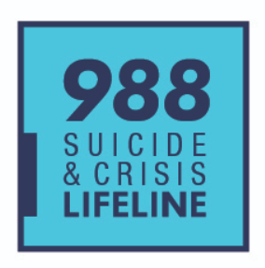

Talk to someone, it’s OKAY to not be okay. There is help!

If you or someone you know is struggling or in crisis:
Call or text 988 or
Chat online at 988lifeline.org
988 is a nation-wide free confidential service that is always available.

You can also call Diversus Health for Same Day Access:
719-572-6100

If you or someone you know is experiencing a
life-threatening emergency call 911.

Go to https://tcmha.org/ for more resources and to learn more about what happens when you call 911 or use the Colorado Crisis Services or the National 988 Crisis Line

during a mental health crisis.

